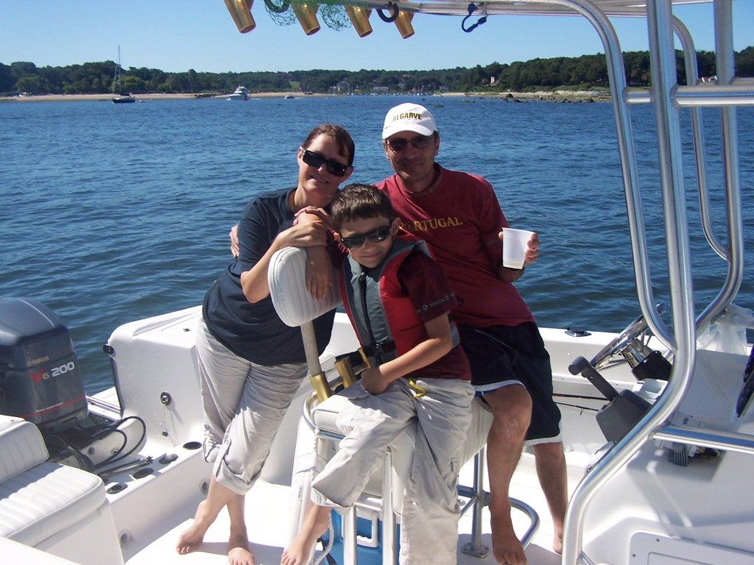
Welcome to our Naples home or The “Florida Bingalow”, as our son Jason likes to call it.

We want your stay to be wonderfully full of special moments, the kind you build memories from.

Feel free to use all of the amenities available here, and never hesitate to call us if we can be of help in any way. Locally you
can always contact our friend and property manager Dari who will be glad to help you with any information you may need, or in case of an emergency.
To get us dial in the USA: 1-845 878 2223
For Dari locally dial 239-438-7425
While in Naples only dial the 438-7425 part if using a local phone.
We can also be reached by email: little_redhouse@hotmail.com
There is much to do and see locally and the beach is just moments away.
Have an amazing holiday.
We are here if you need us.
Cheers from Paul, Dagmar and Jason dos Santos.

