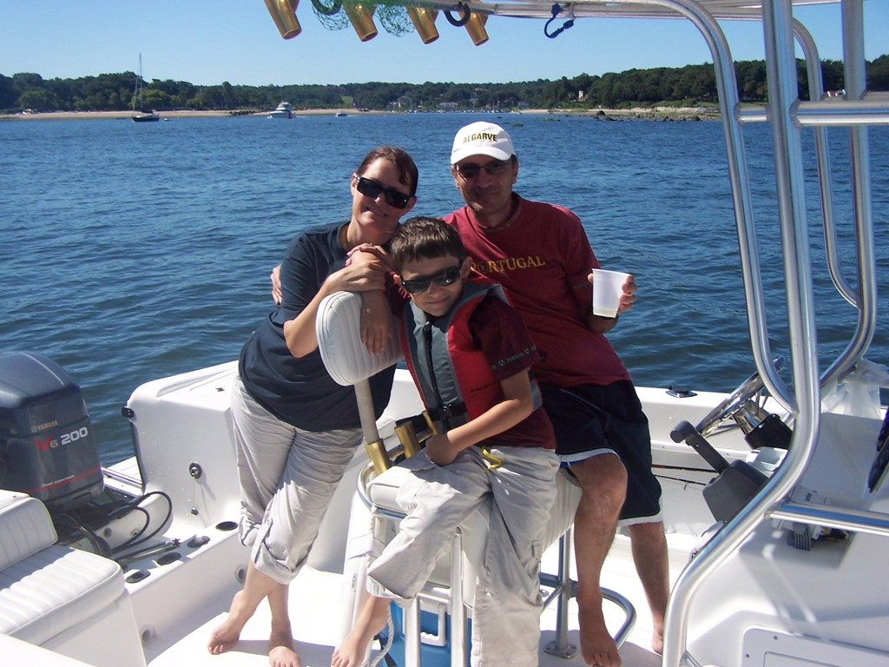
Welcome to our home.

We want your stay to be wonderfully full of special moments, the kind you build memories from.

Feel free to use all of the amenities available here, and never hesitate to call us if we can be of help in any way. Locally you
can always contact our friend and property manager Sarah who will be glad to help you with any information you may need, or in case of an emergency.

To get us dial in the USA: 1-845 216 6854 (5 hour difference your 10AM is our 5AM)

For Sarah locally dial 351-910-538-274
While in the Algarve only dial the 910-538-274 part if using a local phone.

We can also be reached by email: little_redhouse@hotmail.com
There is much to do and see locally and the beach is just moments away.
Have an amazing holiday.
We are here if you need us.
Cheers from Paul, Dagmar and Jason dos Santos.

